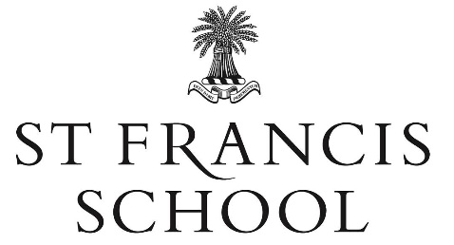

**LEARNING SUPPORT ASSISTANT**

(Fixed Term ending 9th July 2025)

10 hours per week during term time

Required to start 24th February 2025

At St Francis, we want to work with people who are passionate about caring for children, who are energetic and can help us support the development of our wonderful children from birth to 13 years old. Our educational approach to learning blends traditional educational values with innovation and outstanding pastoral care. All of which takes place within 17 acres of superb grounds where our children can climb, run, explore and develop within the space and beauty of our natural environment. We hold an 80-year legacy of providing ‘the best’ for our children and a wealth of success stories.

We are looking to appoint a confident Learning Support Assistant to work with a specific child. Ideally the hours are Monday - Friday, 1pm-3pm, however, there could be flexibility for the right candidate.

This is primarily a pastoral role supporting a child with additional needs. The aim is to enable the pupil to access a broad and balanced curriculum so they have the chance to maximise their achievements and reach their potential.

The successful candidate will fully embrace St Francis School’s vision to educate and inspire children to fulfil their potential. They will work collaboratively with other staff including the Class Teacher and Head of Learning Support, delivering directed interventions and planning and creating alternative resources for the pupil.

Patient, understanding and non-judgemental, the successful applicant will be a strong team player who displays excellent communication skills with children, their parents and colleagues as well as being organised and demonstrating high levels of professionalism. Flexibility and adaptability together with good IT skills and self-motivation will make you a strong contender for this role.

We provide a quality remuneration package including contractual company sick pay and for those meeting the eligibility criteria, a company pension scheme. We have plenty of free parking and provide a healthy and tasty lunch courtesy of our in-house catering team on your days in School.

***Please find the job description and person specification on our website, www.stfpewsey.co.uk.***

***How to apply***

***Applications will only be accepted on the School’s application form which is also available on our website. Early applications are encouraged as the School reserves the right to interview and appoint at any time. Applications should be sent to recruitment@stfpewsey.co.uk***

***St Francis School is committed to safeguarding and promoting the welfare of children. Applicants must be willing to undergo child protection screening appropriate to the post, including checks with past employers and the Disclosure and Barring Service.***